Channel Manager   
  
Channel Manager User Interface Specification

*This document outlines all the possible actions that an end user may perform to fetch and update room information details such as room type, availability and rate via Channel Manager application.*

# Contents

Contents 2

About this document 3

Revisions 3

Distribution 3

Introduction 4

Purpose: 4

Scope: 4

Intended audience: 4

Product Version: 4

Acronyms or abbreviations: 4

System Overview 4

Channel Manager: 4

Services Offered: 4

Technical Specification 9

Request & Response Elements: 10

# About this document

## Revisions

|  |  |  |  |
| --- | --- | --- | --- |
| **Version** | **Date Issued** | **Author** | **Main changes** |
| 1.0 | 04th April 2012 | Senthilnathan | * Initial Version |

## Distribution

This document is intended for distribution to management within Miki Travel only.

This document should not be sent to any party outside of Miki Travel without the agreement of the author.

# Introduction

## Purpose:

The purpose of this document is to give detailed information about the interface of channel manager application which can be used to build external software that utilizes various services provided by channel manager.

## Scope:

Following are identified as the scope of this document:

* Defines the request and response of the interface.
* Defines the interface schema.
* Communication channel/software methodology to interact with the system.

## Intended audience:

* Third Party Suppliers
* Hoteliers

## Product Version:

* 1.0

## Acronyms or abbreviations:

* Channel Manager
* Product (Hotel)
* SubProduct (Room)

# System Overview

## Channel Manager:

**Channel Manager** is a software that allows hotels to manage their inventory and rates for all of their distributors from a single location. This allows the clients to search and book hotels via a controlled system quickly. The application can be accessed online to utilize various services offered.

Channel manager is a robust, high volume, multi-threaded application which is built using latest web technologies in the market. It is a highly flexible, scalable and handles multiple requests and clients in a short span with high performance.

**Note**: As a pre-requisite, the hotels and agreements (with terms and conditions) need to be set up via. another Miki’s application called ‘**HotelNet**’.

## Services Offered:

Channel Manager offers the following three different services:

### GetRoomInformation

This gives the basic details about the list of hotel rooms (sub products) offered by a Hotel (product). Each room is associated with a room id and descriptive name. This is considered as a basic service for channel manager, to access any further information about hotel rooms.

#### Sample XMLs

#### Request XML:

http://www.mikinet.co.uk/interfaceWL/XMLRequest?xml=<?xml version="1.0" encoding="UTF-8"?>

<GetRoomInformationRequest>

<HotelDetails>

<HotelCode>CAH993000</HotelCode>

</HotelDetails>

<Authentication>

<UserName>ABCName</UserName>

<Password>ABCPassword</Password>

</Authentication>

</GetRoomInformationRequest>

#### Response XML:

<GetRoomInformationResponse>

<HotelDetails>

<HotelCode>CAH993000</HotelCode>

<Rooms>

<Room>

<Id>157321</Id>

<Name>Standard Single room: 1 Bed: 1 Pax - River view</Name>

</Room>

<Room>

<Id>157322</Id>

<Name>Deluxe Double room: 1 Bed: 2 Pax - Sea view</Name>

</Room>

<Room>

<Id>157323</Id>

<Name>Standard Twin room: 2 Beds: 2 Pax - Pool view</Name>

</Room>

</Rooms>

</HotelDetails>

</GetRoomInformationResponse>

#### Error Response XML:

<GetRoomInformationResponse>

<Errors>

<Error>

<ErrorCode>101</ErrorCode>

<ErrorText>Invalid user name or password</ErrorText>

</Error>

<Error>

<ErrorCode>102</ErrorCode>

<ErrorText>Invalid Hotel code</ErrorText>

</Error>

</Errors>

</GetRoomInformationResponse>

### GetInventoryInformation

This gives the detailed itinerary/information about the list of hotel rooms along with the rates, availability of a particular Hotel. Through this service, the supplier can get to know the current statuses of the rooms and thus he can amend the rates and availabilities as he wish.

#### Sample XMLs

#### Request XML:

http://www.mikinet.co.uk/interfaceWL/XMLRequest?xml=<?xml version="1.0" encoding="UTF-8"?><GetInventoryInformationRequest>

<HotelDetails>

<HotelCode>CAH993000</HotelCode>

<RequiredDuration>

<StartDate>2012-04-30</StartDate>

<EndDate>2012-05-30</EndDate>

</RequiredDuration>

</HotelDetails>

<Authentication>

<UserName>ABCName</UserName>

<Password>ABCPassword</Password>

</Authentication>

</GetInventoryInformationRequest>

#### Response XML:

<GetInventoryInformationResponse>

<HotelDetails>

<HotelCode>CAH993000</HotelCode>

<RatePlanAndRooms RatePlanId="14241">

<Rooms>

<Room>

<Id>157321</Id>

<Name>Standard Single room: 1 Bed: 1 Pax - River view</Name>

<RoomAvailability>

<AvailableDateAndRate Date="2012-04-30">

<Rate>

<StandardRate Currency="EUR">

<Amount>150.0</Amount>

</StandardRate>

<MinRate Currency="EUR">

<Amount>150.0</Amount>

</MinRate>

<MaxRate Currency="EUR">

<Amount>150.0</Amount>

</MaxRate>

</Rate>

<InventoryAvailable>5</InventoryAvailable>

<ClosedToArrival>true</ClosedToArrival>

<MinStay>1</MinStay>

</AvailableDateAndRate>

<AvailableDateAndRate Date="2012-05-01">

<Rate>

<StandardRate Currency="EUR">

<Amount>160.0</Amount>

</StandardRate>

</Rate>

<InventoryAvailable>7</InventoryAvailable>

<ClosedToArrival>false</ClosedToArrival>

<MinStay>2</MinStay>

</AvailableDateAndRate>

</RoomAvailability>

</Room>

<Room>

<Id>157322</Id>

<Name>Deluxe Double room: 1 Bed: 2 Pax - Sea view</Name>

<RoomAvailability>

<AvailableDateAndRate Date="2012-04-30">

<Rate>

<StandardRate Currency="EUR">

<Amount>200.0</Amount>

</StandardRate>

</Rate>

<InventoryAvailable>3</InventoryAvailable>

<ClosedToArrival>true</ClosedToArrival>

<MinStay>2</MinStay>

</AvailableDateAndRate>

<AvailableDateAndRate Date="2012-05-01">

<Rate>

<StandardRate Currency="EUR">

<Amount>180.0</Amount>

</StandardRate>

</Rate>

<InventoryAvailable>4</InventoryAvailable>

<ClosedToArrival>false</ClosedToArrival>

<MinStay>1</MinStay>

</AvailableDateAndRate>

</RoomAvailability>

</Room>

</Rooms>

</RatePlanAndRooms>

<RatePlanAndRooms RatePlanId="14341">

<Rooms>

<Room>

<Id>157323</Id>

<Name>Standard Twin room: 2 Beds: 2 Pax - Pool view</Name>

<RoomAvailability>

<AvailableDateAndRate Date="2012-04-30">

<Rate>

<StandardRate Currency="EUR">

<Amount>180.0</Amount>

</StandardRate>

</Rate>

<InventoryAvailable>2</InventoryAvailable>

<ClosedToArrival>false</ClosedToArrival>

<MinStay>2</MinStay>

</AvailableDateAndRate>

<AvailableDateAndRate Date="2012-05-01">

<Rate>

<StandardRate Currency="EUR">

<Amount>220.0</Amount>

</StandardRate>

</Rate>

<InventoryAvailable>7</InventoryAvailable>

<ClosedToArrival>false</ClosedToArrival>

<MinStay>2</MinStay>

</AvailableDateAndRate>

</RoomAvailability>

</Room>

<Room>

<Id>157324</Id>

<Name>Deluxe Double room: 1 Bed: 2 Pax - Standard view</Name>

<RoomAvailability>

<AvailableDateAndRate Date="2012-04-30">

<Rate>

<StandardRate Currency="EUR">

<Amount>200.0</Amount>

</StandardRate>

</Rate>

<InventoryAvailable>6</InventoryAvailable>

<ClosedToArrival>true</ClosedToArrival>

<MinStay>1</MinStay>

</AvailableDateAndRate>

</RoomAvailability>

</Room>

</Rooms>

</RatePlanAndRooms>

</HotelDetails>

</GetInventoryInformationResponse>

#### Error Response XML:

<GetInventoryInformationResponse>

<Errors>

<Error>

<ErrorCode>104</ErrorCode>

<ErrorText>No valid rooms found for this search. Please check your input and try again.</ErrorText>

</Error>

</Errors>

</GetInventoryInformationResponse>

### UpdateRateAndAvailabilityInformation

This lets the supplier to provide rates, availability and other additional information for each room in the Hotel. The supplier can use this service whenever they want to add/update rates and availabilities of different rooms of a hotel. The service authenticates the user and check whether the requested hotel and rooms are valid before it process the updates.

#### Sample XMLs

#### Request XML:

http://www.mikinet.co.uk/interfaceWL/XMLRequest?xml=<?xml version="1.0" encoding="UTF-8"?><UpdateRateAndAvailabilityInformationRequest>

<HotelDetails>

<HotelCode>CAH993000</HotelCode>

<RatePlanAndRooms RatePlanId="14241">

<Rooms>

<Room>

<Id>157321</Id>

<Name>Standard Single room: 1 Bed: 1 Pax - River view</Name>

<RoomAvailability>

<AvailableDateAndRate Date="2012-04-30">

<Rate>

<StandardRate Currency="EUR">

<Amount>150.0</Amount>

</StandardRate>

</Rate>

<InventoryAvailable>5</InventoryAvailable>

<ClosedToArrival>true</ClosedToArrival>

<MinStay>1</MinStay>

</AvailableDateAndRate>

</RoomAvailability>

</Room>

<Room>

<Id>157322</Id>

<Name>Deluxe Double room: 1 Bed: 2 Pax - Sea view</Name>

<RoomAvailability>

<AvailableDateAndRate Date="2012-05-01">

<Rate>

<StandardRate Currency="EUR">

<Amount>180.0</Amount>

</StandardRate>

</Rate>

<InventoryAvailable>4</InventoryAvailable>

<ClosedToArrival>false</ClosedToArrival>

<MinStay>1</MinStay>

</AvailableDateAndRate>

</RoomAvailability>

</Room>

</Rooms>

</RatePlanAndRooms>

<RatePlanAndRooms RatePlanId="14341">

<Rooms>

<Room>

<Id>157323</Id>

<Name>Standard Twin room: 2 Beds: 2 Pax - Pool view</Name>

<RoomAvailability>

<AvailableDateAndRate Date="2012-04-30">

<Rate>

<StandardRate Currency="EUR">

<Amount>180.0</Amount>

</StandardRate>

</Rate>

<InventoryAvailable>2</InventoryAvailable>

<ClosedToArrival>false</ClosedToArrival>

<MinStay>2</MinStay>

</AvailableDateAndRate>

</RoomAvailability>

</Room>

</Rooms>

</RatePlanAndRooms>

</HotelDetails>

<Authentication>

<UserName>ABCName</UserName>

<Password>ABCPassword</Password>

</Authentication>

</UpdateRateAndAvailabilityInformationRequest>

#### Response XML:

<UpdateRateAndAvailabilityInformationResponse>

<HotelDetails>

<Status>Success</Status>

</HotelDetails>

</UpdateRateAndAvailabilityInformationResponse>

#### Error Response XML:

<UpdateRateAndAvailabilityInformationResponse>

<Errors>

<Error>

<ErrorCode>105</ErrorCode>

<ErrorText>Invalid input element. Please check your input and try again.</ErrorText>

</Error>

<Error>

<ErrorCode>100</ErrorCode>

<ErrorText>General exception has occured in channel manager application. Sorry for the inconvenience caused. Please try again later.</ErrorText>

</Error>

</Errors>

</UpdateRateAndAvailabilityInformationResponse>

# Technical Specification

**Channel Manager** system is hosted as a web based application that can be accessed via. internet through 'Webservices' call.

Webservices are nothing but a method of communication between two software applications running on a variety of platforms over a network, by following some standards.

Representational state transfer (REST) that uses standard HTTP operations is the type of webservices that need to be used to communicate with channel manager.

## Request & Response Elements:

### GetRoomInformation:

#### Request:

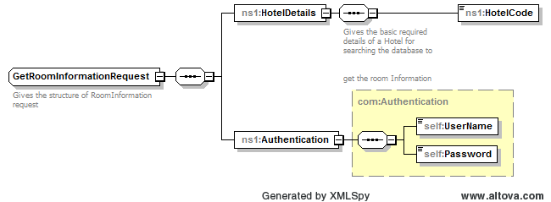

#### Response:

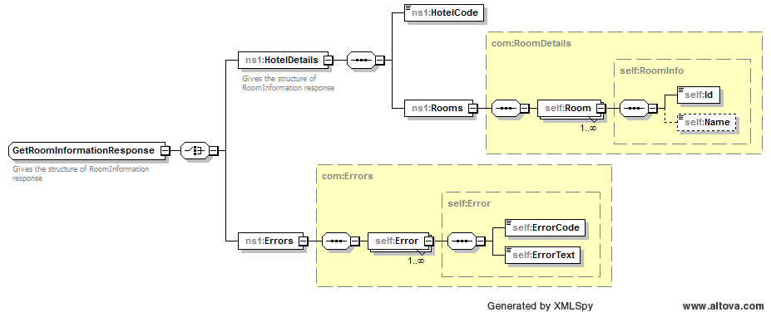

|  |  |  |
| --- | --- | --- |
| **GetRoomInformationV1** | | |
| **Type** | **ElementName** | **Meaning** |
| GetRoomInformationRequest | HotelDetails/HotelCode | The property code |
| Authentication/UserName | Name of the registered supplier  for authentication |
| Authentication/Password | Password of the registered  supplier for authentication |
| GetRoomInformationResponse | HotelDetails/HotelCode | The property code |
| HotelDetails/Rooms/Room/Id | Unique room identification number |
| HotelDetails/Rooms/Room/Name | Detailed name of the room |
|  |  |
| Errors/Error/ErrorCode | Unique error identification number |
| Errors/Error/ErrorText | Descriptive information about the error |

### GetInventoryInformation:

#### Request:

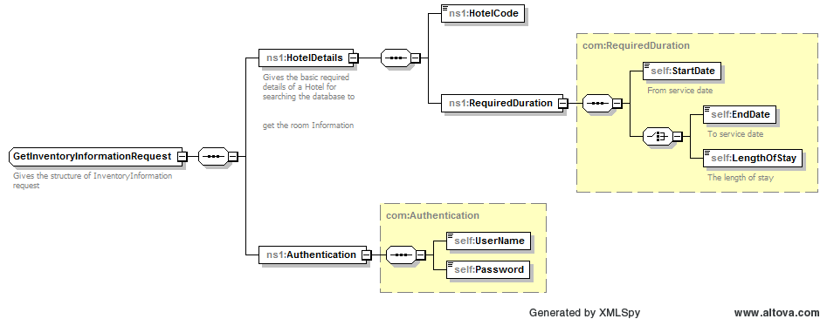

#### Response:

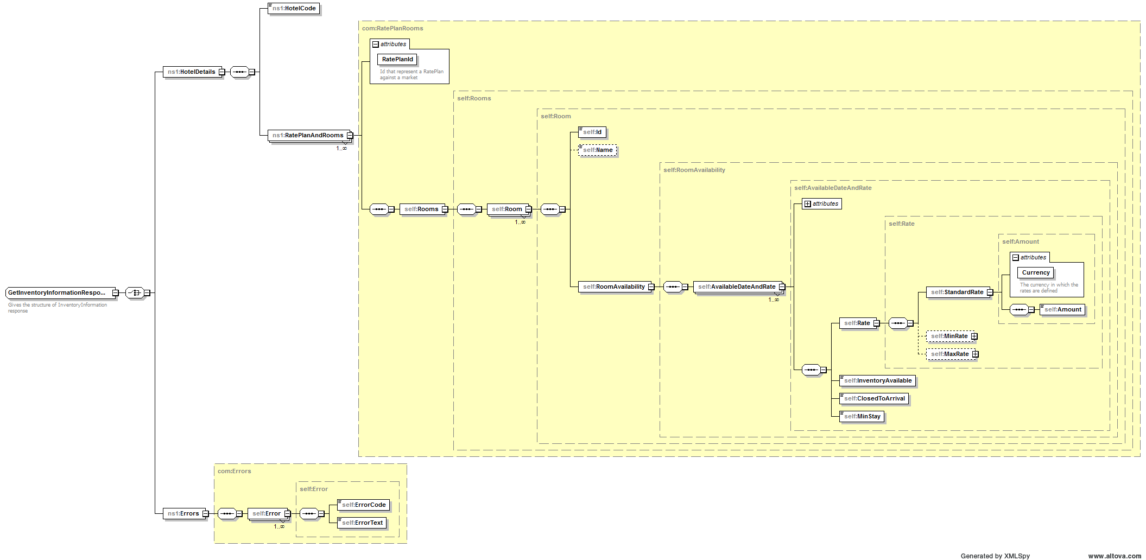

|  |  |  |
| --- | --- | --- |
| **GetInventoryInformationV1** | | |
| **Type** | **ElementName** | **Meaning** |
| GetInventoryInformation Request | HotelDetails/HotelCode | The property code |
| HotelDetails/RequiredDuration | Duration of the rooms required  for servicing |
| HotelDetails/RequiredDuration/StartDate | Required start date of the service |
| HotelDetails/RequiredDuration/EndDate | Required end date of the service |
| HotelDetails/RequiredDuration/LengthOfStay | Required length of the service |
| Authentication/UserName | Name of the registered supplier for authentication |
| Authentication/Password | Password of the registered supplier for authentication |
| GetInventoryInformation Response | HotelDetails/HotelCode | The property code |
| HotelDetails/RatePlanAndRooms | Gives the complete rate & availability details for each  applicable RatePlan |
| ./RatePlanId | Unique registered rateplan identification number |
| ./Rooms/Room | Gives the list of rooms with all the details like rate, availability for the corresponding service date |
| ../Room/Id | Unique room identification number |
| ../Room/Name | Detailed name of the specific room |
| ../RoomAvailability | Gives the rate & availability details for all the applicable service date of a particular room |
| ../RoomAvailability/AvailableDateAndRate | Gives the rate & availability details for a specific service date of a particular room |
| …/AvailableDateAndRate/Date | The date on which the room is serviced |
| …/AvailableDateAndRate/Rate/Amount/Currency | The currency code of standard rate |
| …/AvailableDateAndRate/Rate/Amount/Amount | The standard rate |
| …/AvailableDateAndRate/Rate/MinRate/Currency | The currency code of minimum selling rate |
| …/AvailableDateAndRate/Rate/MinRate/Amount | The minimum selling rate |
| …/AvailableDateAndRate/Rate/MaxRate/Currency | The currency code of maximum selling rate |
| …/AvailableDateAndRate/Rate/MaxRate/Amount | The maximum selling rate |
| …/AvailableDateAndRate/InventoryAvailable | Number of available rooms |
| …/AvailableDateAndRate/ClosedToArrival | To indicate whether reception is available or not on the particular date |
| …/AvailableDateAndRate/MinStay | Minimum number of days to stay |
|  |  |
| Errors/Error/ErrorCode | Unique error identification number |
| Errors/Error/ErrorText | Descriptive information about the error |

### UpdateRateAndAvailabilityInformation:

#### Request:

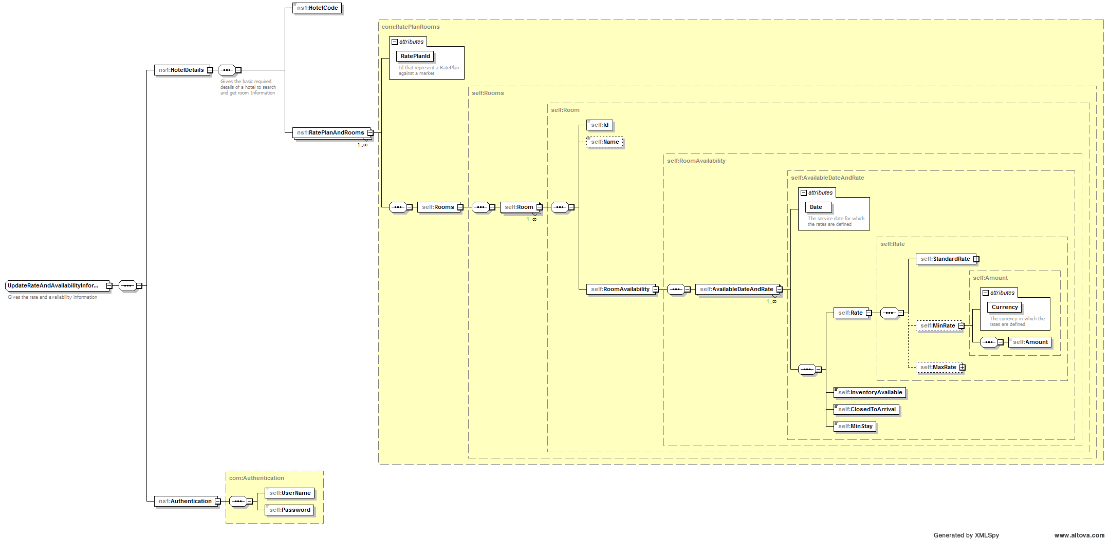

#### Response:

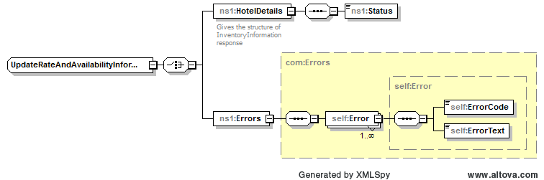

|  |  |  |
| --- | --- | --- |
| **UpdateRateAndAvailabilityInformationV1** | | |
| **Type** | **ElementName** | **Meaning** |
| UpdateRateAndAvailability InformationRequest | HotelDetails/HotelCode | The property code |
| HotelDetails/RatePlanAndRooms | Gives the complete rate & availability details for each applicable RatePlan |
| ./RatePlanId | Unique registered rateplan identification number |
| ./Rooms/Room | Gives the list of rooms with all the details like rate, availability for the corresponding service date |
| ../Room/Id | Unique room identification number |
| ../Room/Name | Detailed name of the specific room |
| ../RoomAvailability | Gives the rate & availability details for all the applicable service date of a particular room |
| ../RoomAvailability/AvailableDateAndRate | Gives the rate & availability details for a specific service date of a particular room |
| …/AvailableDateAndRate/Date | The date on which the room is serviced |
| …/AvailableDateAndRate/Rate/Amount/Currency | The currency code of standard rate |
| …/AvailableDateAndRate/Rate/Amount/Amount | The standard rate |
| …/AvailableDateAndRate/Rate/MinRate/Currency | The currency code of minimum selling rate |
| …/AvailableDateAndRate/Rate/MinRate/Amount | The minimum selling rate |
| …/AvailableDateAndRate/Rate/MaxRate/Currency | The currency code of maximum selling rate |
| …/AvailableDateAndRate/Rate/MaxRate/Amount | The maximum selling rate |
| …/AvailableDateAndRate/InventoryAvailable | Number of available rooms |
| …/AvailableDateAndRate/ClosedToArrival | To indicate whether reception is available or not on the particular date |
| …/AvailableDateAndRate/MinStay | Minimum number of days to stay |
|  |  |
| Authentication/UserName | Name of the registered supplier for authentication |
| Authentication/Password | Password of the registered supplier for authentication |
| UpdateRateAndAvailability InformationResponse | HotelDetails/Status | Status of the response (e.g Success) |
|  |  |
| Errors/Error/ErrorCode | Unique error identification number |
| Errors/Error/ErrorText | Descriptive information about the error |

### Schemas:

Find below the schemas for the three services:



### Errors & Exceptions:

The expected error codes & error messages for the application are shown below:

|  |  |  |
| --- | --- | --- |
| **Sl.No** | **Error Code** | **Error Message** |
| 1 | 101 | Invalid user name or password. |
| 2 | 102 | Invalid hotel code. |
| 3 | 103 | No valid agreement exists for the requested hotel. Please check your input. |
| 4 | 104 | No valid rooms found for this search. Please check your input and try again. |
| 5 | 105 | Invalid input element. Please check your input and try again. |
| 6 | 100 | General exception has occurred in channel manager application. Sorry for the inconvenience caused. Please try again later. |

### Contact Details:

For any queries and clarifications, please contact the following support team.

1. XXX Email – XXX@group-miki.com
2. YYY Email – YYY@group-miki.com