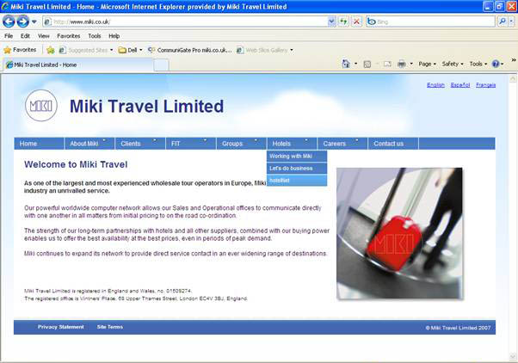
Go to www.miki.co.uk and select Hotels tab, then HotelNet

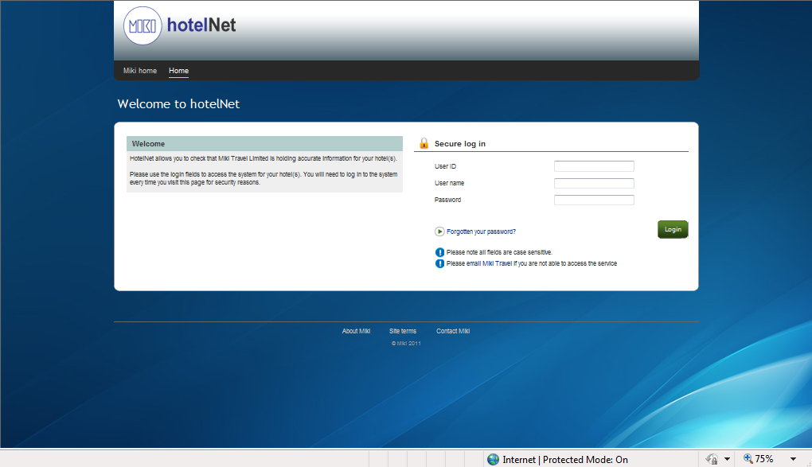
Log on by inputting your User Id, User Name and Password as supplied previously.
You might be prompted to change your given password (first time log in only)!

SINGLE HOTEL USER:

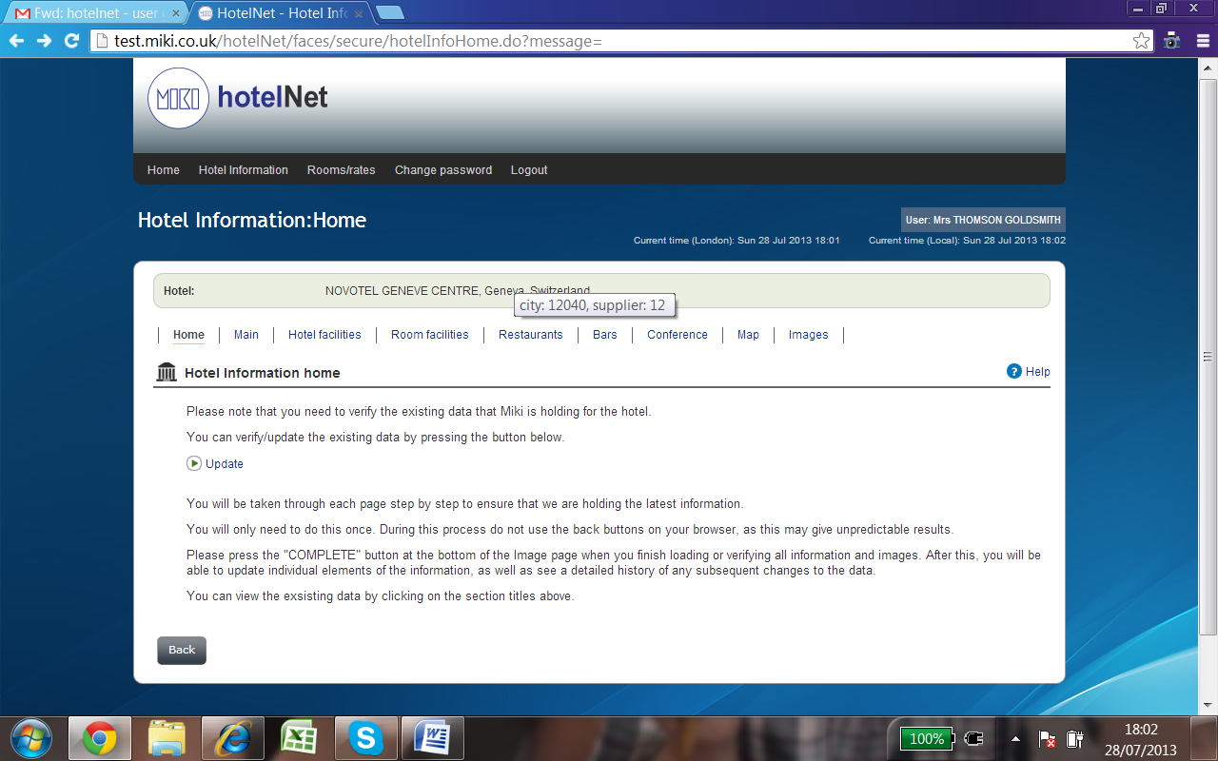 Select the “Rooms and rates ” tab. You will be taken to the allotment page.

ROOMS TOP UP

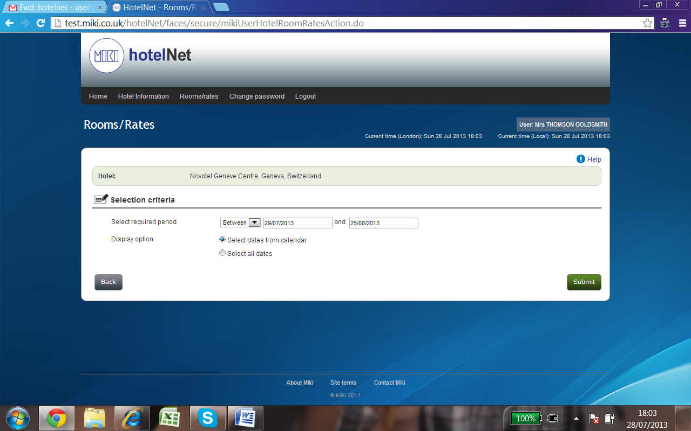Select the date range you require.
Select dates from the calendar OR select all dates.
From the calendar you must select (tick) the required dates and click Submit!

- You can select specific days of the week or a combination of
- You can select whole weeks
- You can select the whole period/month by ticking the boxes next to the relevant section/date.

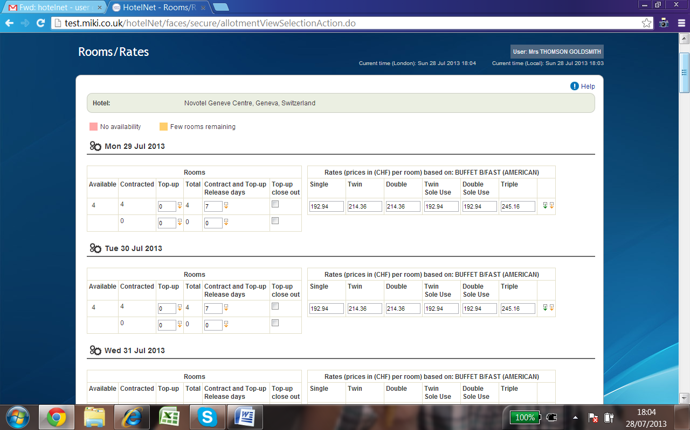

Add extra rooms on the second line under Top-up column.
If the original contracted allocation is split into two releases you can top up either on first or second line.

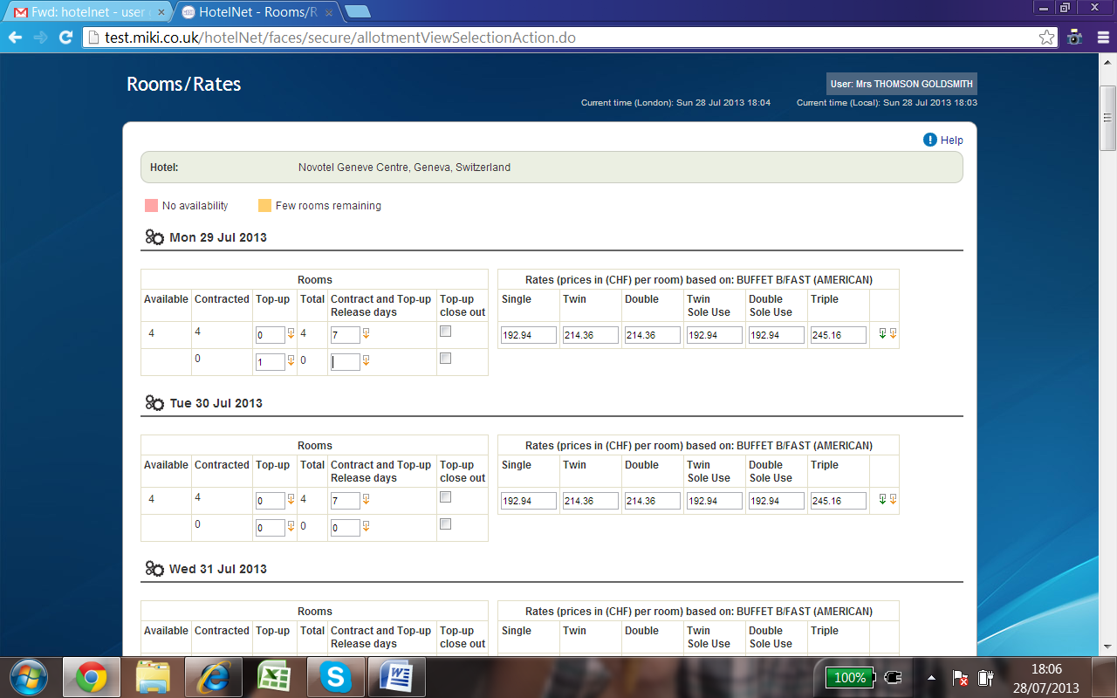
Please note the minimum release day is 1 day!

Please note that if you reduce the release days this will also reduce the contracted rooms’ release and you will be unable to increase without contacting us!

Please select Submit to proceed with your amendments. Confirm and proceed!

If adding the same number of rooms or inputting the same number of release days for multiple dates you can use the cascade function:

RATE ADJUSTMENTS
You can reduce the rates by changing the rates as displayed on the screen:
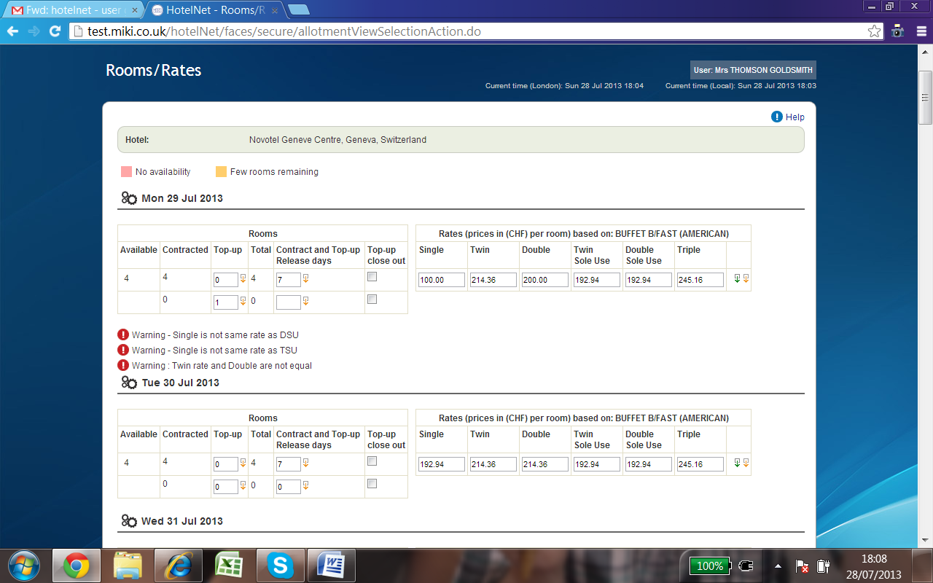

Please note you can only reduce the original contract rate or increase the reduced rate up to the original contract rate.

You will see that there are some warning messages showing as the single is not the same rate as TSU/or DSU and Twin and Double are not equal. These rates can still be entered if they are correct by pressing submit.

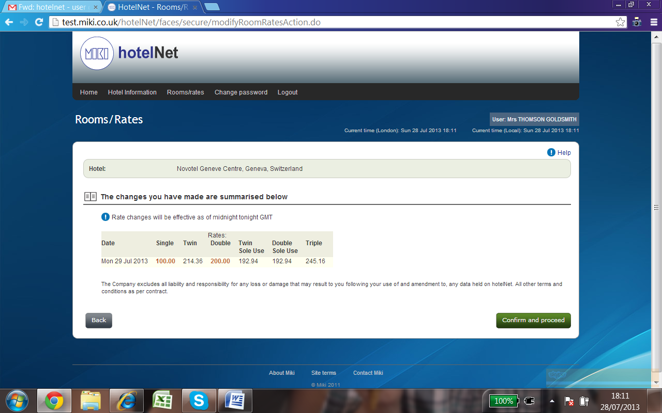

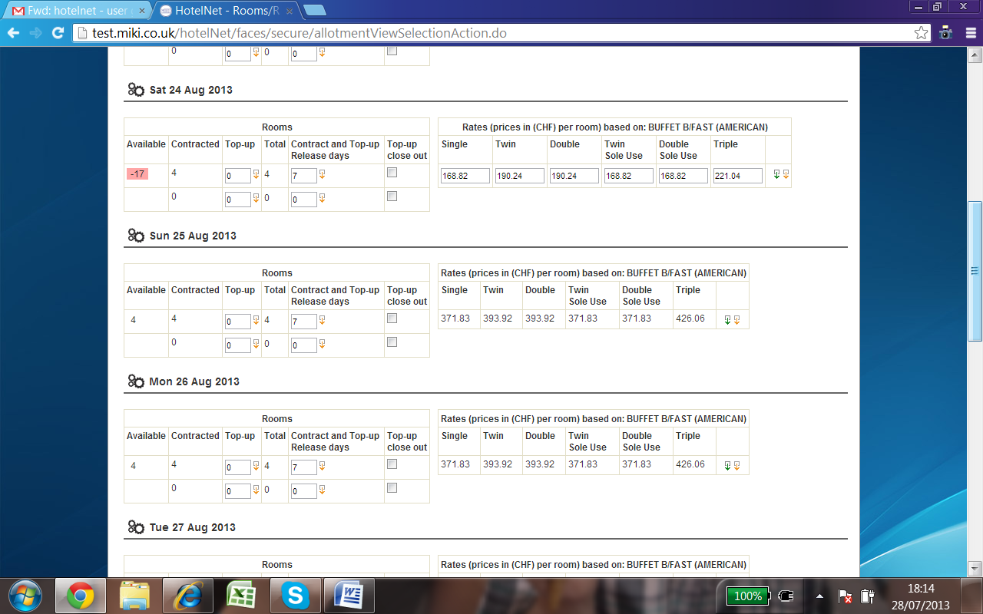

Some rates are not possible to be modified and this is because they are Fair Rates
To modify rates during fair periods please contact Miki Travel.

Different markets

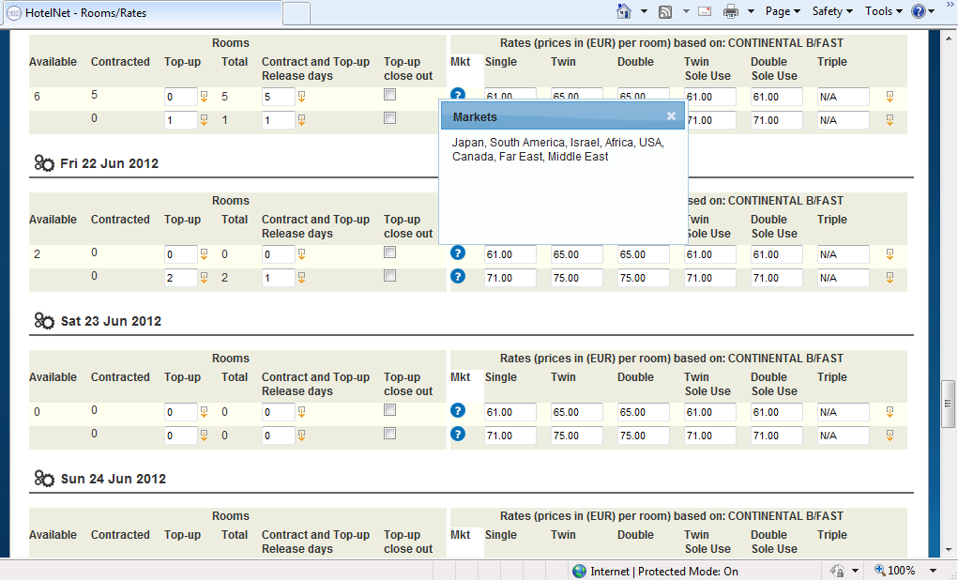

Please amend rates for various contracted markets if applicable. If the rates are valid for all markets than no specific markets are shown.

Please confirm and Submit when done.

Cascade function:

Copy and Cascade direct

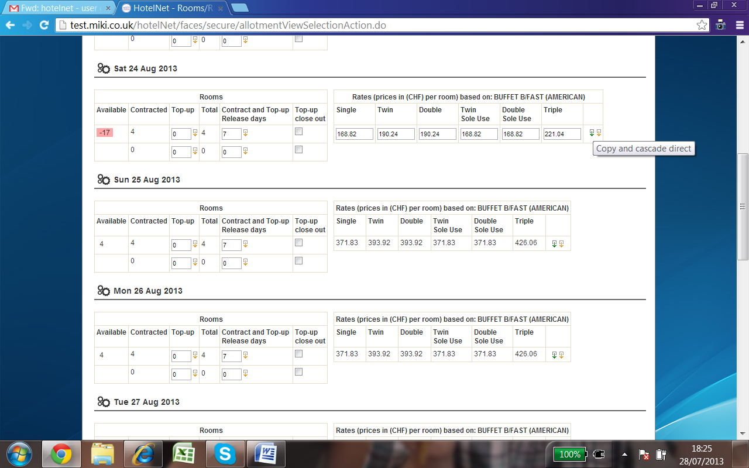

By selecting the green arrow – this copies the information on the rates line to all other dates below the line you have amended.

Copy and Cascade by day

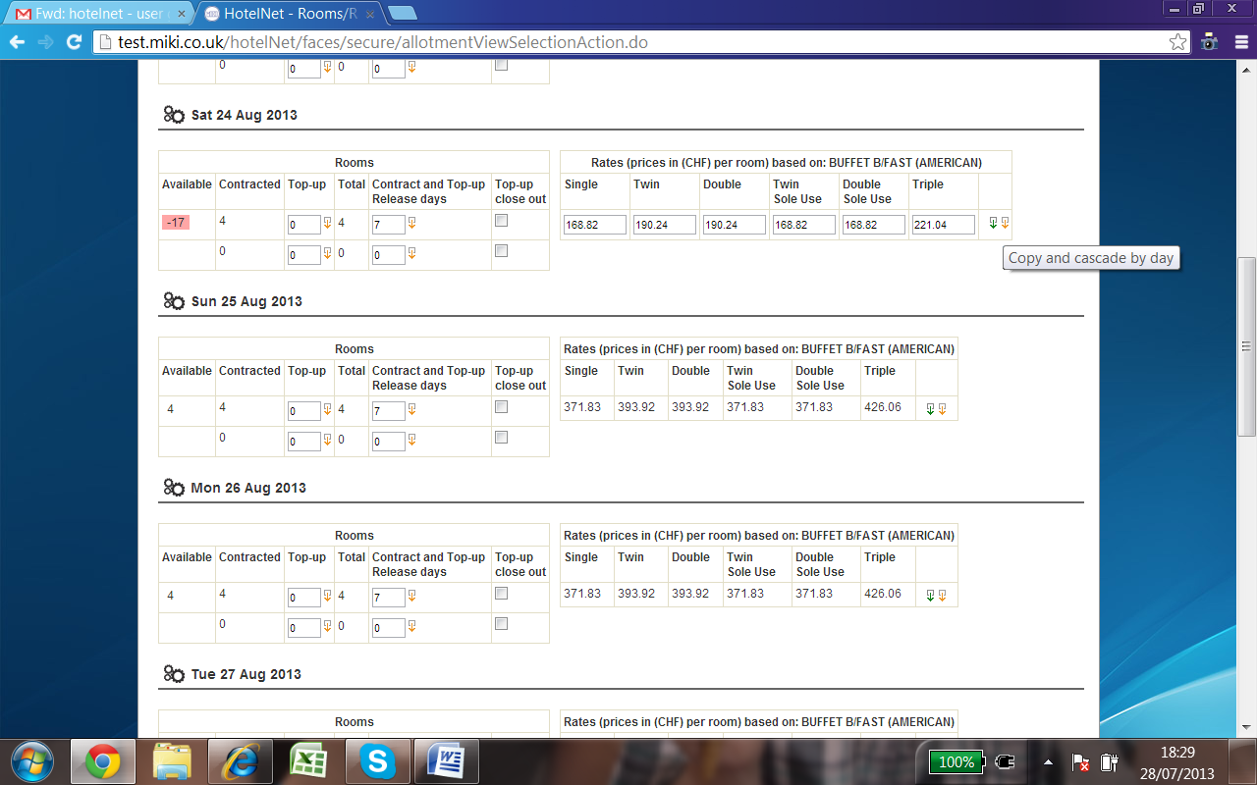

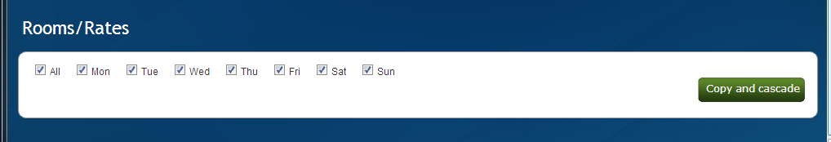

Selecting the yellow arrow - gives you a pop up screen to choose the days of the week you want to copy to.
By selecting the days you want the rates information will copy to the selected days listed below.

MULTI HOTEL USERS:
Multi Hotel users will have same functionality as Single Hotel Users except the sign on screen is displayed as follows:
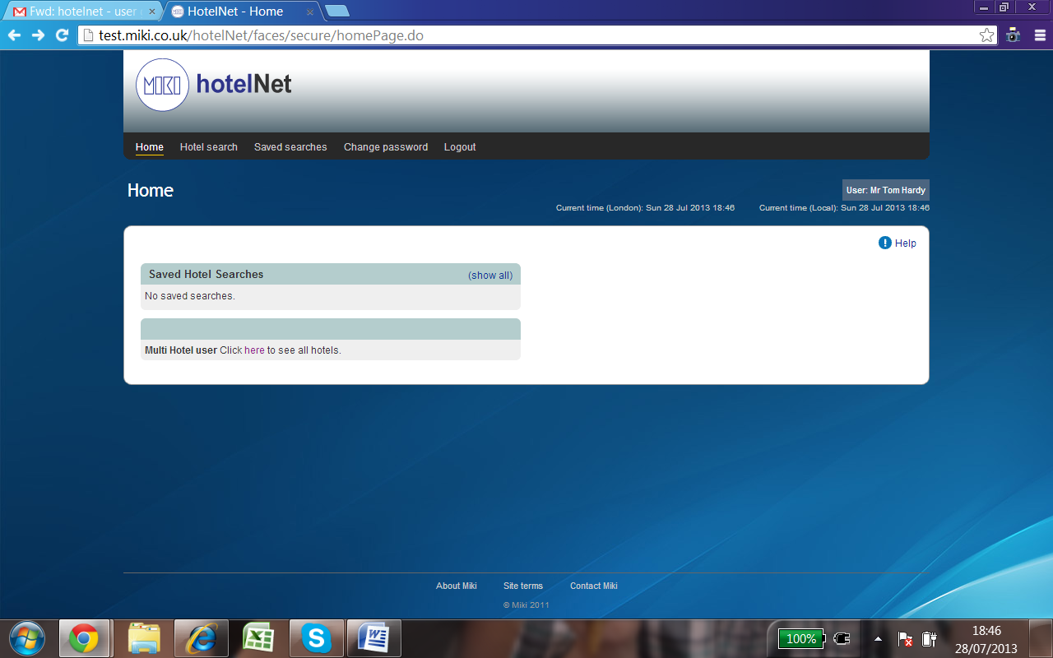
Click to see all hotels
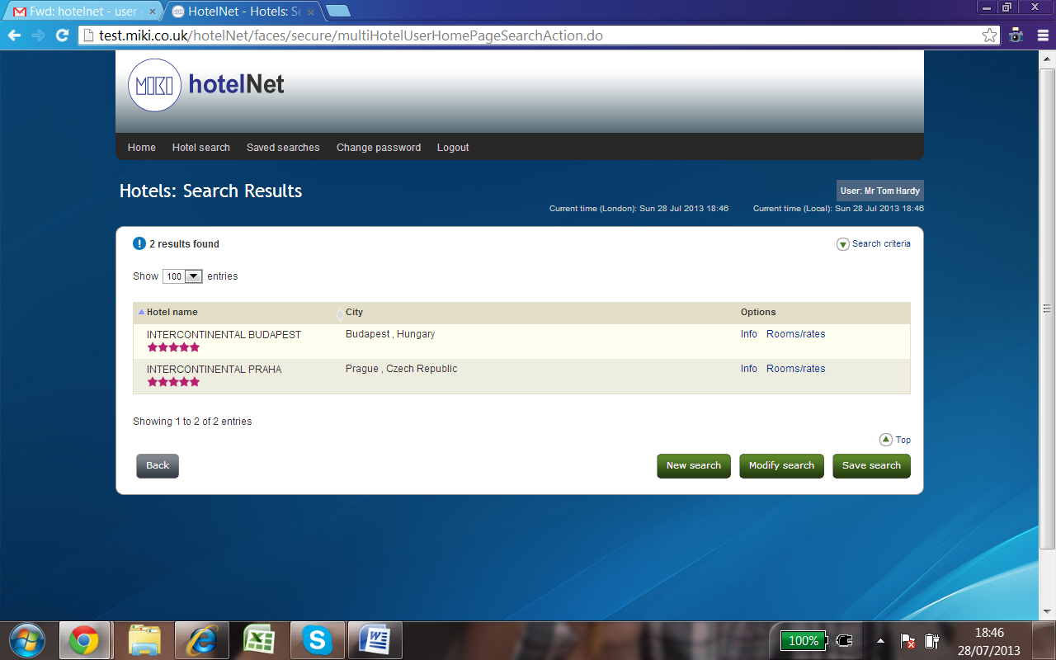
Then choose Rooms/rates - Which will take you to the calendar page to select dates.

