# Setup of new credit card account for White label website

In order to setup new credit card account for a white label website,

* Go to mikiCMS > Manage websites
* Select “Settlement currencies” from the drop down list of the website
* Click on “Add new settlement currency” link at the top of the page

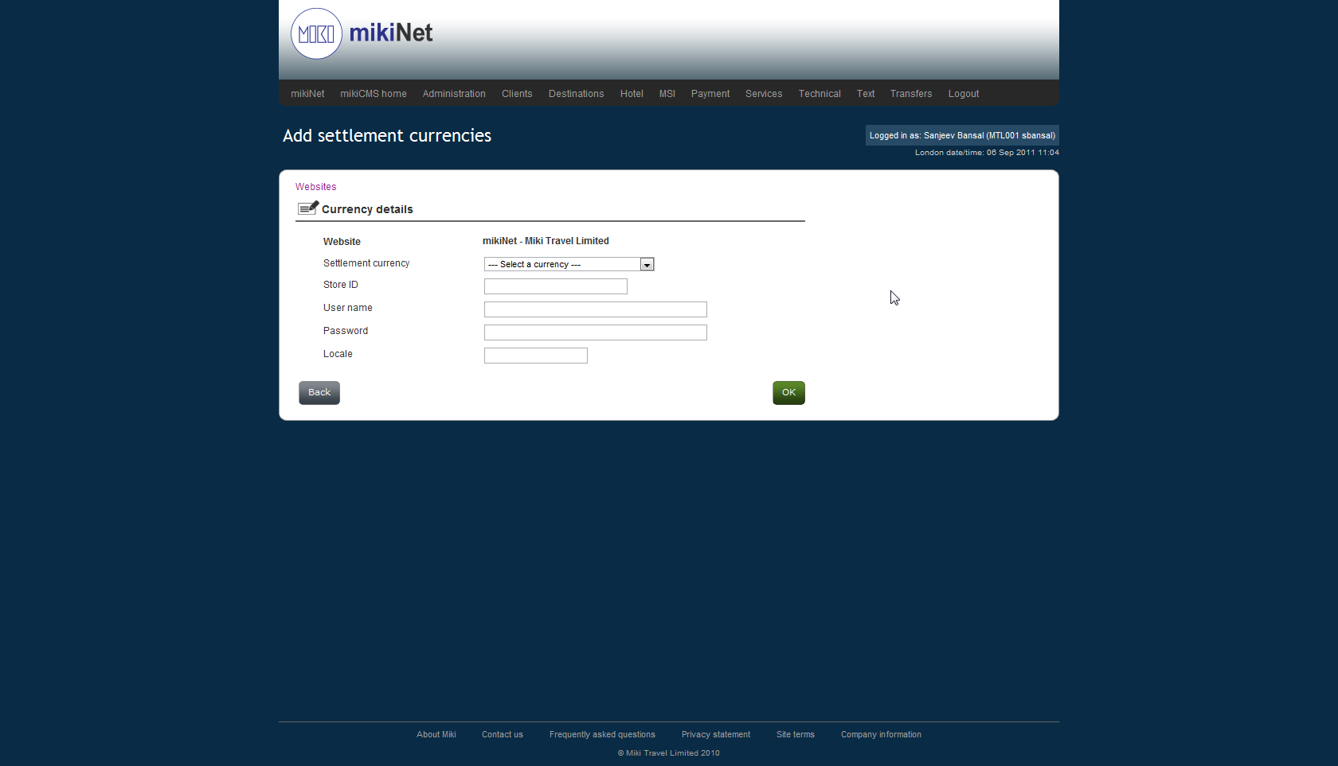

* Select currency from the drop down menu, enter store id, username, password, locale (currency code from Barclays) and press “ok”.
* In order to Accounts scheduler to pick this account for settlement a new record should be added to “***ebzBarclaysAccountsToSettle***” table.

One account can be used on multiple websites but needs to be added separately for each website.

Cache refresh is required in order to use the newly added account.