Authority control for mikiNet
This document explains how different functions are control on mikiNet.

Contents

Contents 2
About this document 3
Revisions 3
Distribution 3
Introduction 4
Function 5
Sub function 6
Adding authority to any function on mikiNet 8
Authorise users to a particular function 9

About this document

Revisions

Version | Date Issued | Author | Main changes
1.0 | 11/01/2010 | Sanjeev Bansal | - Initial Revision

Distribution
This document is intended for distribution to management within Miki Travel only.
This document should not be sent to any party outside of Miki Travel without the agreement of the author.

Introduction

Different functions are authority controlled on mikiNet. Each user needs to be authorised in order to access most of the functions on mikiNet.

This is controlled via Functions and Sub functions. This functionality is available on mikiCMS.

Admin/mikiCMS/Manage Functions

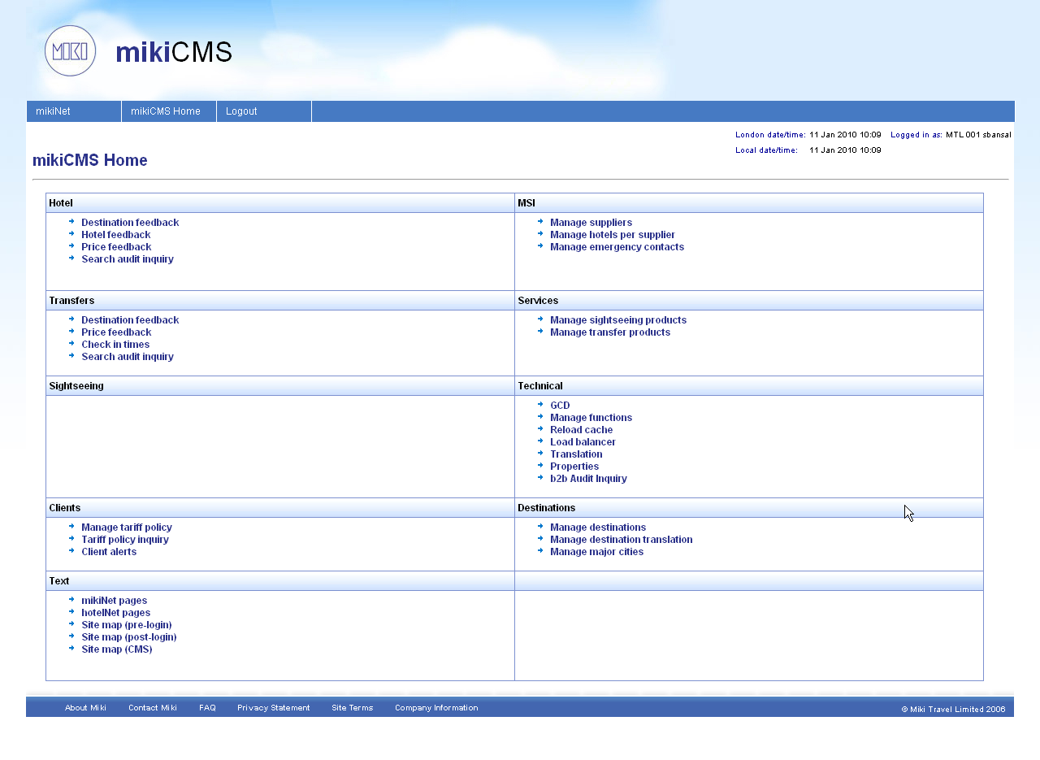

Function

In order to add a new Function click on “Add new function” link on Work with functions page on mikiCMS.

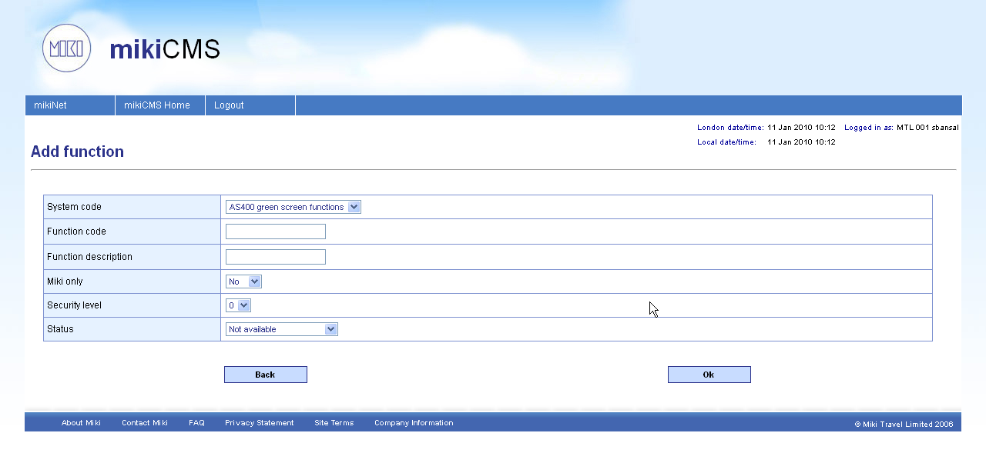

Following data needs to be entered in order to create a new function

System code | Select a system where this function will be available. To create a new function which will be available on mikiNet please choose “Agent site”.
Function code | Enter any unique function code.
Function description | Enter description for the function.
Miki only | Select “Yes” if this function will only be available for Miki users.
Security level | Select security level.
Status | Select status.

Sub function

After adding a new function we need to add a sub function. To add a new sub function first search for the recently added function from “Work with functions” page.

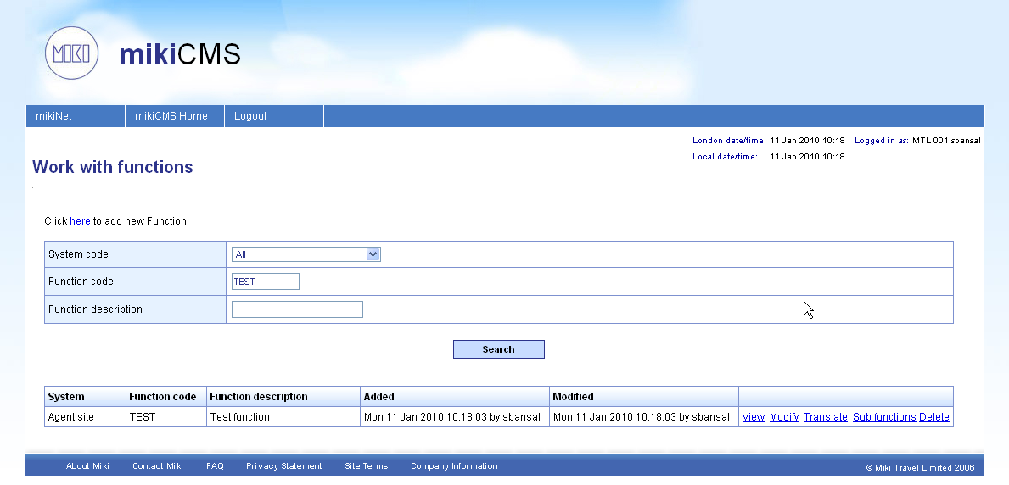

Then click on “Sub function” link against the newly added function and click “Add new sub function” link from the next page.

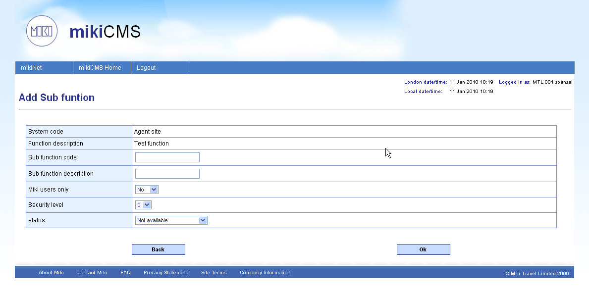

Following data needs to be entered in order to create a new sub function

Sub function code | Enter any unique sub function code.
Sub function description | Enter description for the sub function.
Miki only | Select “Yes” if this function will only be available for Miki users.
Security level | Select security level.
Status | Select status.

Adding authority to any function on mikiNet

After adding function and sub function we can add code to restrict particular function on mikiNet.

We should use security.tld tag library to add authority control on mikiNet pages. Define security tag library in jsp like this

<%@ taglib uri="/WEB-INF/custom-tld/security.tld" prefix="sec" %>

And then use following tag to control the function

<sec:authCheck function="TESTbFunction="TEST-SF”>
</sec:authCheck>

Anything coded between sec:authCheck tag will only be available to the users which are authorised to the specified function.

Authorise users to a particular function

In order to give access to a particular function to mikiNet user we need to modify the user authority which can be done via User search on mikiNet.

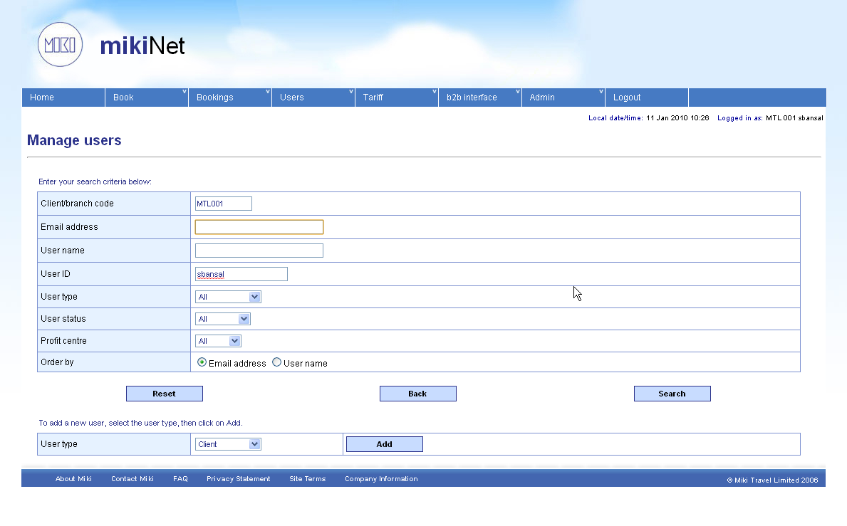

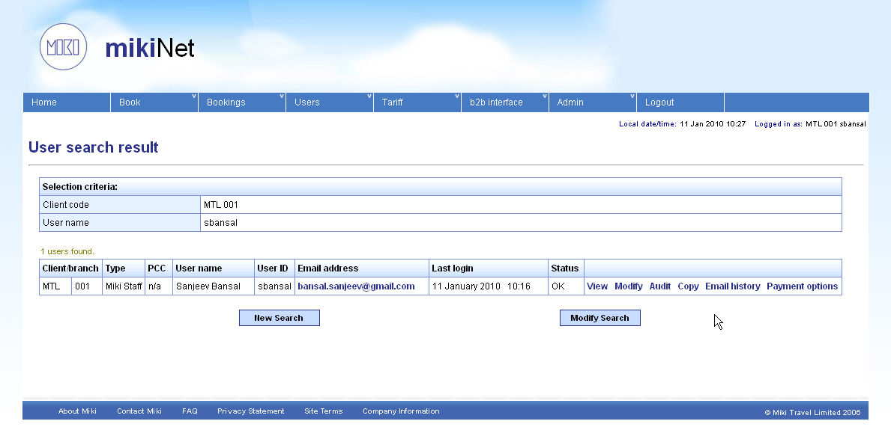

Click on “Modify” link against user on user search results page.
No need to change anything on the next page. Click “OK”.

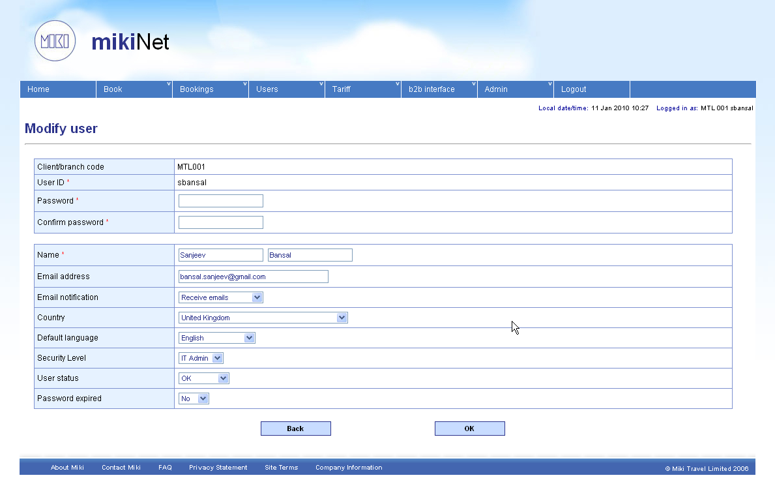

On the next page you will find the newly added function/sub function if within the security level of the selected user. Check the box against the function/sub function you need to give authority to the user and click ok.

