Local DB2 Express configuration for development environment

Contents

Contents 2
About this document 3
Revisions 3
Distribution 3
Introduction 4
Overview 4
Local Database 5
JDBC Resources 7
Data Sources 7
Environment 7
EBizDAO 7

About this document

Revisions

Version | Date Issued | Main changes
1.0 | 10th Feb 2010 | Initial Revision

Distribution
This document is intended for distribution to IT staff within Miki Travel and Miki Solutions only.
This document should not be sent to any party outside of Miki Travel or Miki Solutions without the consent from the authors.

Introduction

Overview
A DB2 Express database running on a local development workstation is introduced in an attempt to shorten the start-up time for a local WAS.

This document explains necessary steps to set up a DB2 Express database, new configurations in IRAD, and a new java project used to import data from the test database to the local database.

Local Database

1) Install a copy of DB2 Express on your workstation. Choose the admin user name as EBZTSTDTA, and set the password to mikib2c. Accept the default settings for other steps.

2) Once the installation is done, log in to your workstation as EBZTSTDTA. Launch the control centre for DB2 Express. Create a new database by right click on the All Databases node and select Create Database > Standard.
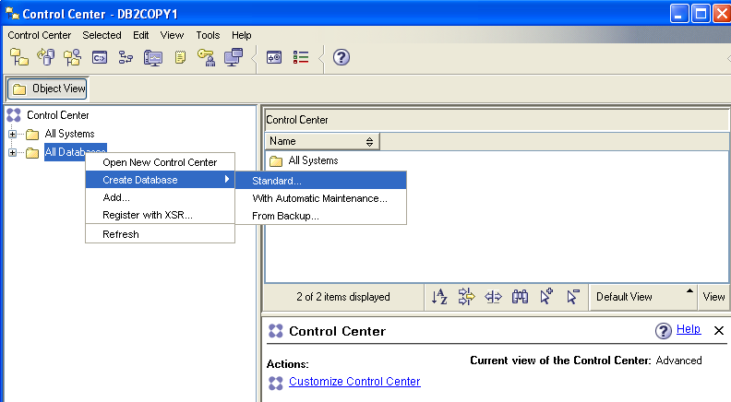

3) Specify the database name as TSTDB01. Then set Default bufferpool and table space page size to 32K. Click Finish to create the database.
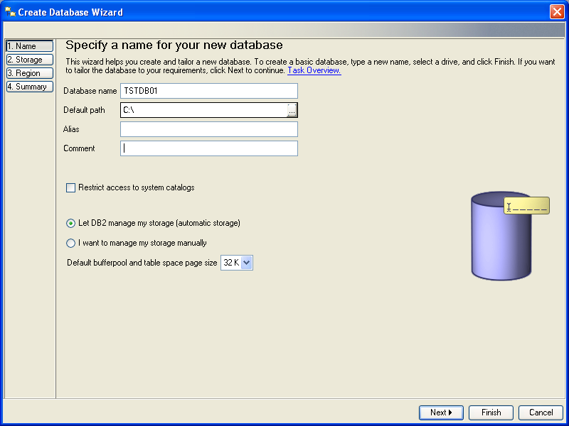

4) Navigate to the Schemas folder in TSTDB01. Click Create new Schema and supply EBZTSTDTA for the schema name and authorization name.
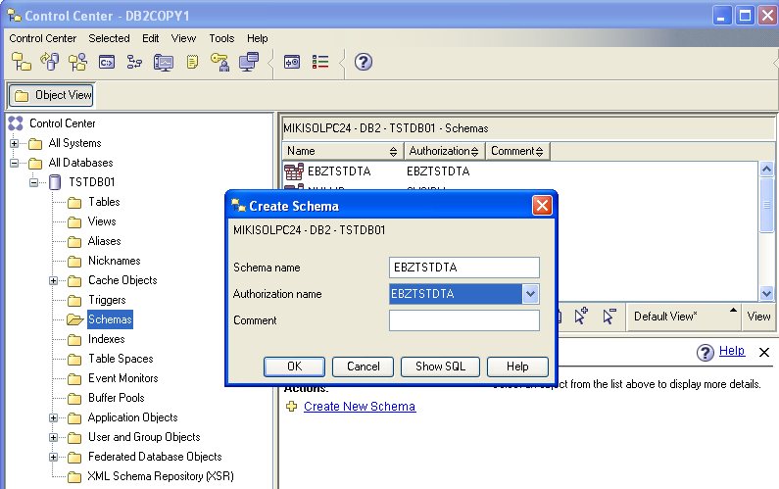

5) Once you have the database and its schema, log back in to your workstation as yourself. Launch IRAD, and check out the EBizDatabaseImport project from the head.

6) Run DataMoverUtility. The code will create tables and populate them with a copy of data from the test database. These tables are needed for data caching during the initialisation of the application.

7) When the data import is done, open createView.sql in the EBizDatabaseImport project and copy the script to create a new view in TSTDB01.
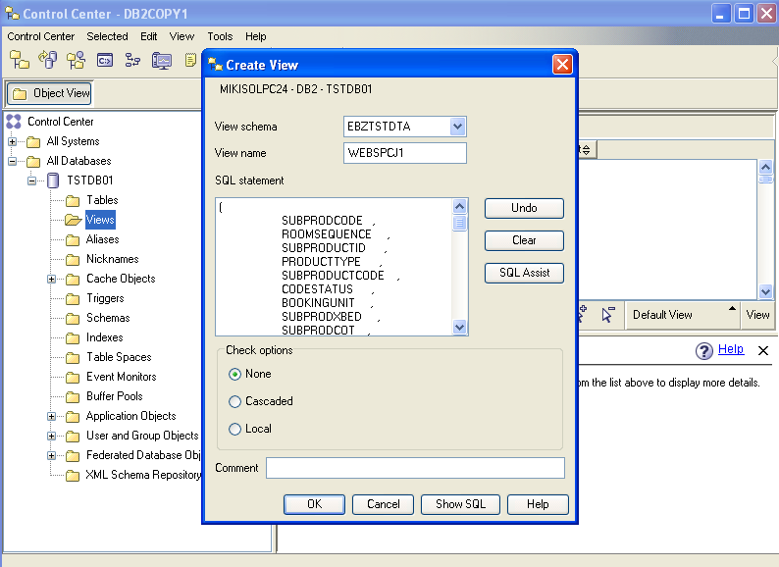

JDBC Resources
Create a new database driver for DB2 Express in IRAD administrative console as the following.
Go to Resources > JDBC Providers and click New to create a new driver using the following values.

Database type : DB2
Provider type : DB2 Universal JDBC Driver Provider
Implementation type : XA Data source
Name : DB2 Universal JDBC Driver Provider (XA)

Data Sources
In IRAD administrative console, go to JDBC providers > DB2 Universal JDBC Driver Provider (XA) > Data sources. Set up a new data source for the local database using the following configurations.

Name | JNDI Name | Component-managed authentication alias | Container-managed authentication alias | Server name
lcdev | jdbc/lcdev | EBZTSTDTA | EBZTSTDTA | localhost

Use the following values for DB2 Universal data source properties.
Database Name : TSTDB01
Driver Type : 2
Server Name : localhost
Port Number : 50000
**Note: if driver type 2 does not work, try 4.

Environment
1) Copy db2jcc.jar and db2jcc_license_cu.jar from C:\Program Files\IBM\SQLLIB\java or your DB2 EXPRESS HOME to C:\jars\

2) In IRAD administrative console, go to Environment > Websphere variables > DB2UNIVERSAL_JDBC_DRIVER_PATH and set the value to C:\jars\

3) Save changes and test connection for lcdev.

EBizDAO
A database properties file needs to be modified to utilise the local DB2 Express database. Locate DatabaseAccess-test.properties (if your server role is set to 2) in the EBizDAO project. Update the following key/value pairs.

resourcesDataJNDIName=jdbc/lcdev
localDatabaseJNDIName=jdbc/lcdev

